**The “Downtowner”**

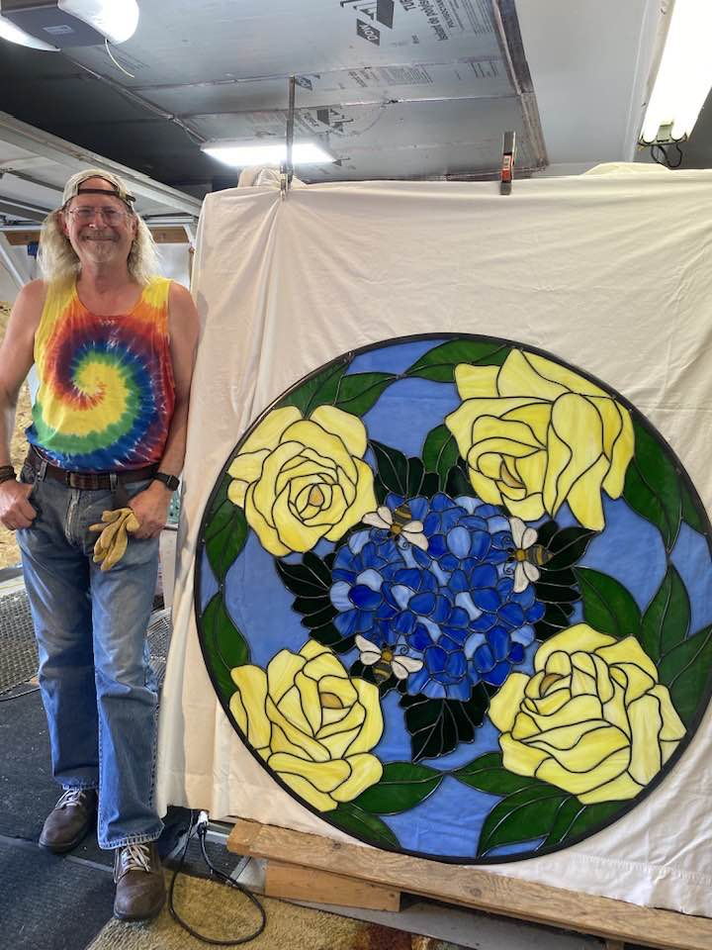

**KIWANIS CLUB OF ROCHESTER, Rochester, MN** [www.kiwanisroch.org](http://www.kiwanisroch.org)

# August 13, 2023

Coming Programs

Circle of Service for August,

Dan Carlson (needs some help)

**BBob McClocklin passed away July 23. Our Kiwainis Club was a big part of his life for many years. I knew him 25 years ago when my wife and I moved to Rochester from Michigan. He was active then as a member and officer. But, most of the years, I knew him as “Mr. Peanut Man” for our club. I had the job of setting up the Peanut sales about 3 years and then Bob (and Suzie) stepped in. To me he was the ultimate project manager beginning with ordering of the peanuts, then getting the club members to do their job. He and Suzie were very active at the time of the sales distributing collection pails and advertising aprons. He would have all the collection points figured where they would most likely have the best traffic and potential income. I don’t know how many years Bob delivered my few boxes to my home door. You can see what I mean.**

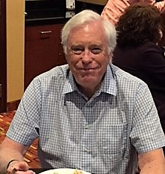

**Not only was he a good manager of his Kiwanis office (President, I don’t know what year) he was a great fund raiser for our Club’s many money demands. There are over 300 non-profit groups in Rochester, all with worthy goals and money needs. Our Kiwanis’s biggest demand for funds has been the issuing of scholarships to students going on to college. It was a happy time at Christmas when he guided us for appropriate donation of time and funds.**

**He and Suzie were usually active at our Christmas party and/or gift wrapping.**

**You will be missed, Bob**

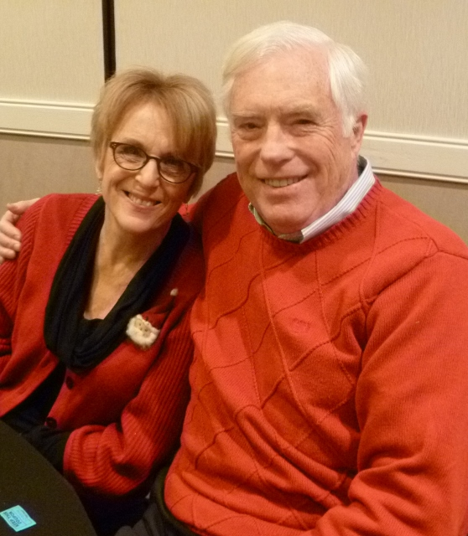

**A**CTIVE MEMBERS Home Office or Cell

# Austinson, Paul 288-8735 273-5518

[**pjaustinson43@gmail.com**](mailto:pjaustinson43@gmail.com)

Borcherding, Don 282-1783 259-2679

[dpborcher@hotmail.com](mailto:dpborcher@hotmail.com)

Carlson, Dan 285-1098 272-5215

[Danhope3904@msn.com](mailto:Danhope3904@msn.com)

Graham, Charlie***** 507 358-8567 [Cgraham120@charter.net](mailto:Cgraham120@charter.net)

Hull, Linda 282-8399

[lindahull1025@yahoo.com](mailto:lindahull1025@yahoo.com)

Ilvedson, Ronald*** 529-0551 [peterturkel@gmail.com](mailto:peterturkel@gmail.com)

Jorgenson, Austin **Secretary** 413-2134

[Austj4@gmail.com](mailto:Austj4@gmail.com)

Kalmes, Bill **Treasurer** 289-4056 288-3277

[w.kalmes@smithschafer.com](mailto:w.kalmes@smithschafer.com) cell 951-7552

Krsnak, Roger **Co-President** 2023 282-2872 358-5020

[rdkrsnak@me.com](mailto:rdkrsnak@me.com) cell 358-5020

Lawson, Del 951-4006

[drdel22@aol.com](mailto:drdel22@charter.net)

Lun, Al **Webmaster** 289-3937 507-269-3853

[albert.lun@gmail.com](mailto:albert.lun@gmail.com)

Maddox, Colleen **Co-President** 287-0318 280-7911 (cell)

[landherrmaddox@gmail.com](mailto:landherrmaddox@gmail.com)

Nehring, Irv 775-6857 cell 226-1494

[inehring@frontiernet.net](mailto:inehring@frontiernet.net) **Auditor & Budget Advisor**

Nelsen, David 533-0225

[perryford90@yahoo.com](mailto:nrockford9@aol.com) cell 815-243-1223

Nelson, Daniel 507-884-9829

[dan61nelson@gmail.com](mailto:dan61nelson@gmail.com)

Schultz, Bonnie 280-6078 529-4830

[bonnies@uwolmsted.org](mailto:bonnies@uwolmsted.org)

Tompkins, Mary cell 273-5012

[Mtompkins14@charter.net](mailto:Mtompkins14@charter.net)

Warren, Clare, 254-2087

[Clarew60@gmail.com](mailto:Clarew60@gmail.com)

16 Active members as of Oct 2023

*Senior Member **Privileged Member ***Honorary Member

****Senior & Long Term Perfect Attendance

*****Life Member

The preceding list reflects the official roster of active members according to Kiwanis International. If a name is missing or one is present that should not be, please let C. Warren know. ***District & International web sites:***

[***www.kiwanis.org***](http://www.kiwanis.org/) [www.mndak.org](http://www.mndak.org)

***Jim Bouquet 651-560-4292

***Bob Fiss 288-7480

The Kiwanis Club of Rochester meets every Thursday at the Meeting Room at the Eagles

917 15th St. SE

Meetings last about one hour. Lunch is served including an entree, fruit, salad, and drink for ($14.00 )

~~~~~~~~~~~~~~~~~~~~~~~~~~~~~~~~~~~~~~~~~~~~

***Newsletter Changes***

*Remember to call* ***Clare Warren at 254-2087*** *if you have anything you feel is newsworthy. We are trying to get the newsletter out every other week. It can be effective if you feed in the right information. Feel free to contribute something for publication!*

Be sure to read the roster once in awhile and report any errors to C. Warren

***Why not!*** *If you have a computer, why not try to receive the Kiwanis* ***Newsletter via e-mail.*** *It is a quick and easy way for us to get the letter to you on time. We now have 17 ACTIVE members receiving it regularly. They enjoy the ability to get it in COLOR.*

at [www.kiwanisroch.org](http://www.kiwanisroch.org) 2022-23



*Colleen Maddox*

*Roger Krsnak Co- Presidents*

*Immed. Past Presidents*

*Austin Jorgenson*

*Bill Kalmes Treasurer*

*??? Secretary*

***Committees***

***Club Rep to District***

***Membership, Growth & Education***

***Public Relations***

***Community Services***

***Youth Service & YCPO***

*,*

***Programs***

*Circles of Service*

***Human and Spiritual Values***

***Finance***

***Donations/Charities***

***Co-Presidents next yr. are***

***(Still no names for co-Presidents for next year)***

No more detail about the children reading plan except that Bonnie and Linda read to a group of children this past week. They had a great time, but always need more readers. We could use a picture of one of these reading groups with their reader. I promise to try to match the correct readers and audience for the Newsletter.

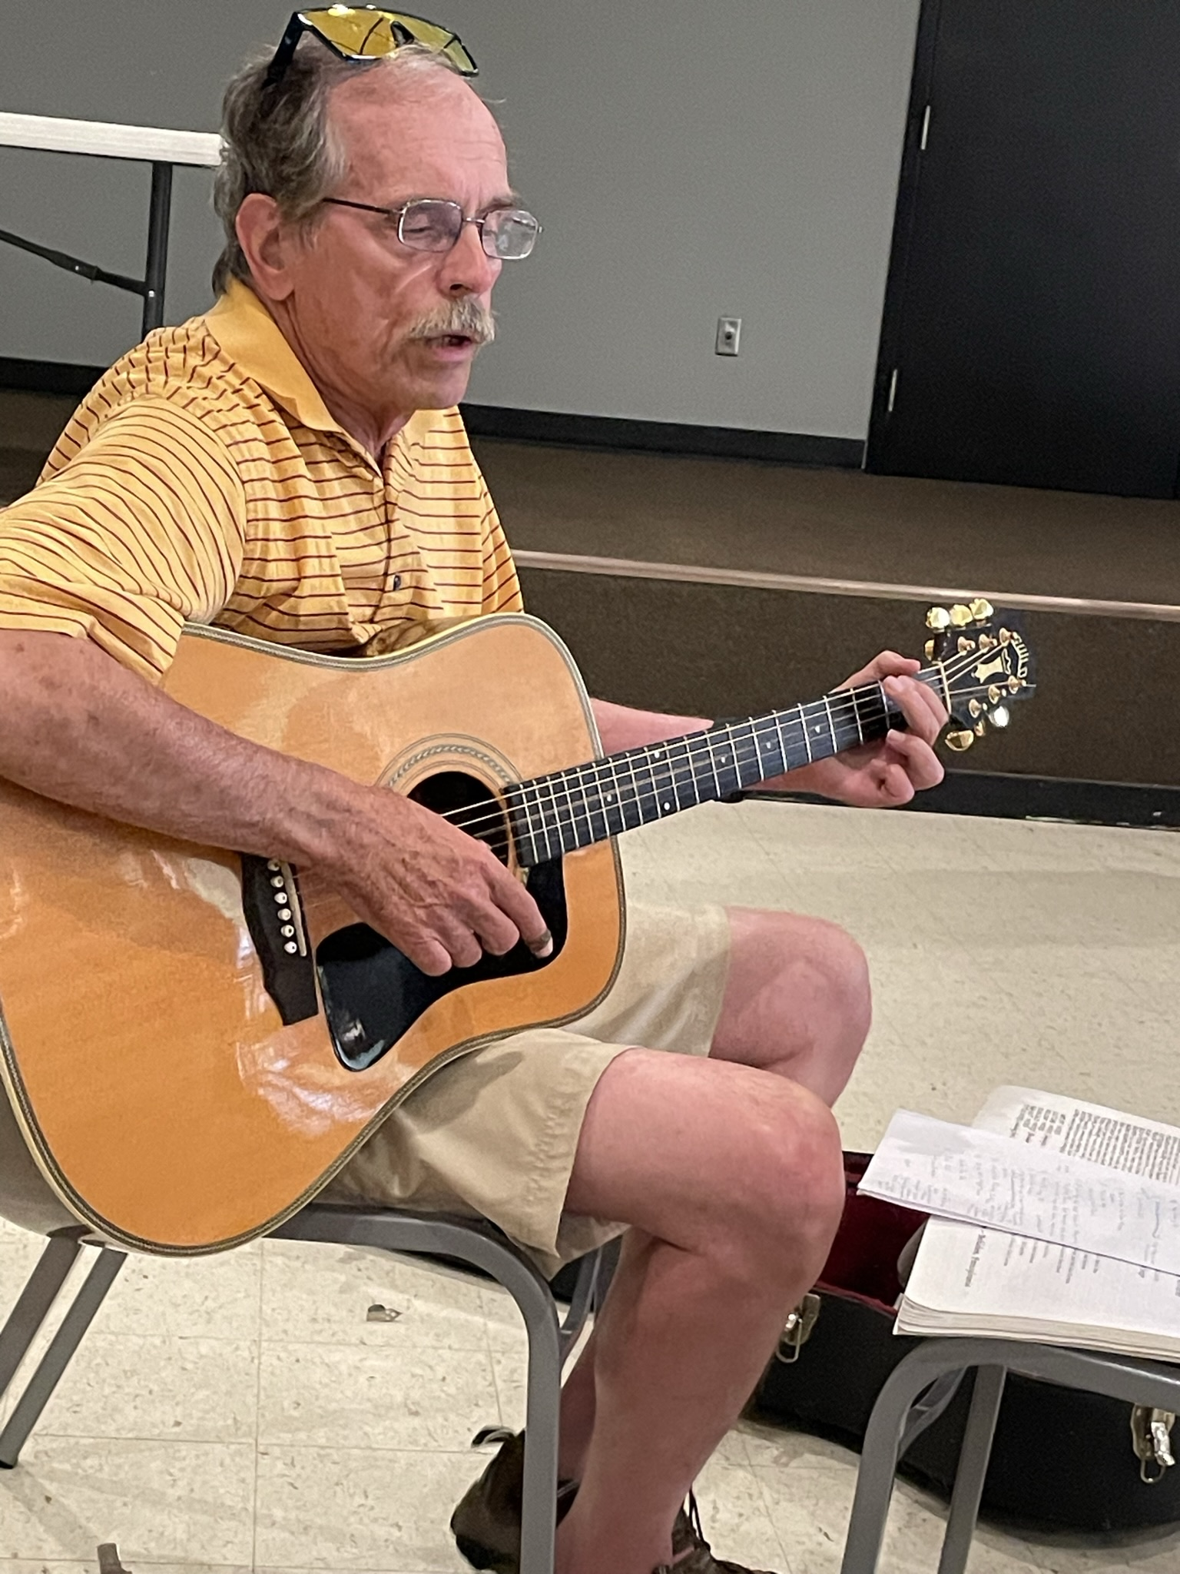

“Johnny Cash” Carlson was here last week with a demonstration and program on his guitars. Dan continues to amaze us with his love for children among many other things. This past week Dan did his program on the importance and start of his church in Rochester. I tend to miss details, but think it was a reference to Autumn Ridge Church, last known as the Baptist Church on 12th st. SW

If I’m wrong, I know someone will let me know. We tease Dan a bit on his skill in telling stories of the past, but he is so good at it. He got deserted on the Circle of Service programs this summer. We need to be sure that schedule is filled out and followed.

**It is difficult for the editor on the NL to post things like programs approaching and menu without a good line of communication all the way through every month. It’s not hard or time consuming.

Just send the information to the president, Colleen, Clare or some other designated person. They can email the information on entire club list.

************

Dave Nelsen had a veteran, Wayne Kammerer as a guest. I got a good picture of him, but it is among others that I don’t know. So, just acknowledging the visit and inviting his return.

**Peanut Sale will be Labor Day weekend.The date and times list has been circulated.**

**Remember the cost is the same as usual.**

**$25 a box. They are Peanut bars this year. I don’t know what will be passed out to each contributor, but we will be clear on that by next meeting.**

**The sale is at HyVee W. Circle Dr. as in the past year.**

**You recall that our club sent Money to the United Way for the Backpack for Kids program. They needed more funds, so we voted to send them $200 more. Motion made and passed.**

**President Austin reported that his trip to Alaska with a total of 17 family members was a trip of a lifetime. There some hitches in the flight plans, but all worked out as you might expect.**

**Austin was back in the President’s saddle this past week. We are very happy that the big trip went acceptably well.**

**(He** welcomed us with the invocation about the importance of indigenous people in this world. )

