**The “Downtowner”**

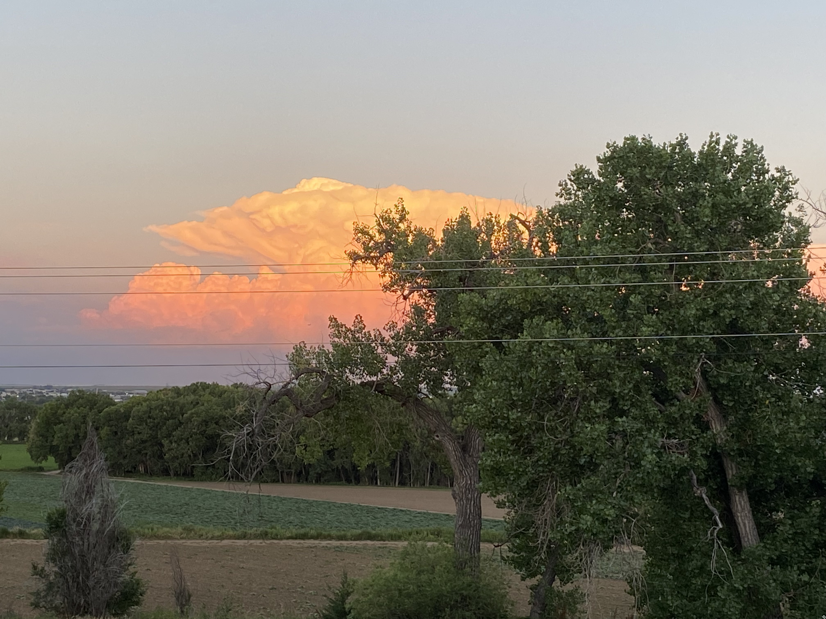

**KIWANIS CLUB OF ROCHESTER, Rochester, MN** [www.kiwanisroch.org](http://www.kiwanisroch.org)

# July 20, 2023

Coming Programs

Circle of Service for July:

June: Dan Carlson, Bonnie Schultz

Rummage Sale a Huge Success!

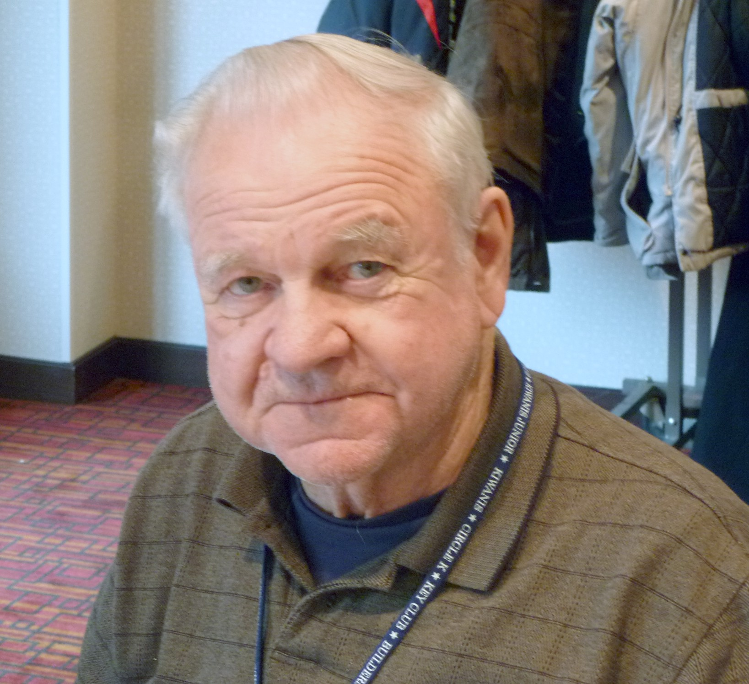

That was the headline last issue.Just to verify that this year’s success was not a fluke, Pres. Austin made a pitch for adding electronics to our collecting for next year. He says that the U.S. shortage on precious metals is hurting our economy. Most of the precious metals used in the electronics industries are found in the greatest quantities in China and other Asian countries. Austin has gathered a few things and taken in for re-cycling. He has started a nest-egg for next year’s sale. So, there is our invitation for an easy fund raiser for next year. Just check your own unwanted electronics and get the word out that we are doing something new to raise funds for the youth of the world. FYI, we raised $2400 from the rummage sale this year.

**Vern Skare was the Veteran guest of David Nelsen last week. It’s my understanding that he will be scheduled to speak a few words about his experiences soon. Always good to honor a veteran.**

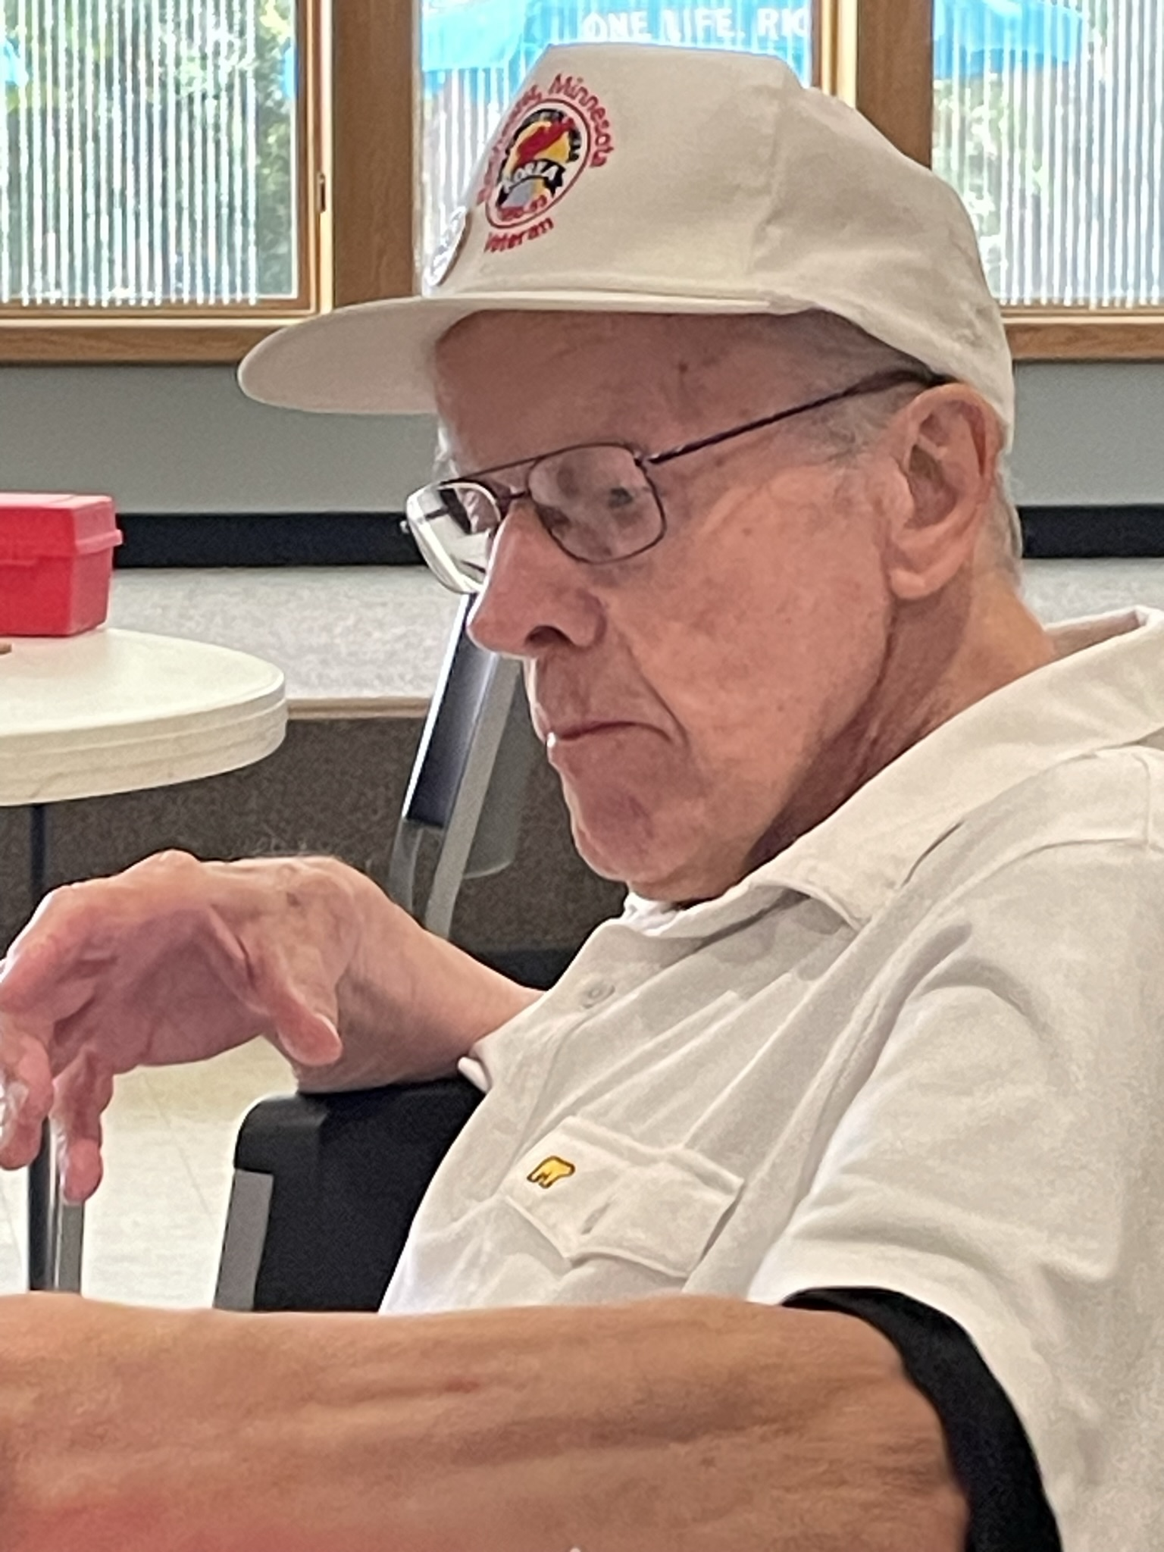

**Our Kiwainis has contributed to the “Running Start” program for a number of years. This was run through United Way. They provided backpacks and supplies for students of need each beginning school year. The program is now being run differently. The United Way buys from a company who sells the backpacks fully supplied with the things the kid needs. They then sell them to groups that were accustomed to doing that as a group work project.**

**It was moved and supported that our club send the United Way $200 toward those supplies. Carried unanimously.**

**\*\*\*\*\*I have been receiving notes from the following Copyright attorney.It has been passed on to Austin J. This guy says we owe his business over $700 for copyright infringement of several photos that I have used from Google for our club newsletter. If any of you are familiar with this procedure, step up and say something. They have recommended that we seek Legal Advice.**

## Copyright Claim Heading Towards Litigation - RQ2OLR

Kiwanis

Search for all messages with label Kiwanis

Remove label Kiwanis from this conversation



|  |  |  |  |  |
| --- | --- | --- | --- | --- |
| |  | | --- | | Higbee & Associates Copyright Claims <claims@higbee.law> | | Mon, Jul 17, 5:00 PM (5 days ago) |  | Reply |
| |  | | --- | | to me | | | |

We have mailed you a letter and sent four follow-up emails about the unauthorized use of our client’s copyrighted materials. Despite multiple offers to try to resolve the matter with you, we have not heard from you.    Please call us or email us now.

This is not as scary as it may seem.    Each month we work with hundreds of businesses like yours to resolve these claims in a manner that is fair for everyone.   Unfortunately, each month, we end up suing businesses that ignore our client's claims.

You are still welcome to call us or go to our secure online Resolution Center and either make a payment or let us know why you believe you do not owe money for using our client’s work.

Please call us or go to our secure online resolution center and either make a payment or let us know why you believe you do not owe money for using our client’s work.

Website: <https://copyright.higbeeassociates.com/resolution>

Username: RQ2OLR

Password: w8nsk618

Sincerely,

Mathew K. Higbee  
Attorney at Law

**Speak up somebody! This guy seems serious.

Law Firm of Higbee & Associates  ([http://www.higbeeassociates.com](http://www.higbeeassociates.com/))  
1504 Brookhollow Dr., Suite 112, Santa Ana, CA 92705  
Phone: (800) 716-1245

Higbee & Associates is a national law firm with an A+ rating with the Better Business Bureau. Our lead attorney, Mathew Higbee, has been licensed to practice law since 2006. We have 21 offices across the country. Our headquarters is in Santa Ana, California.

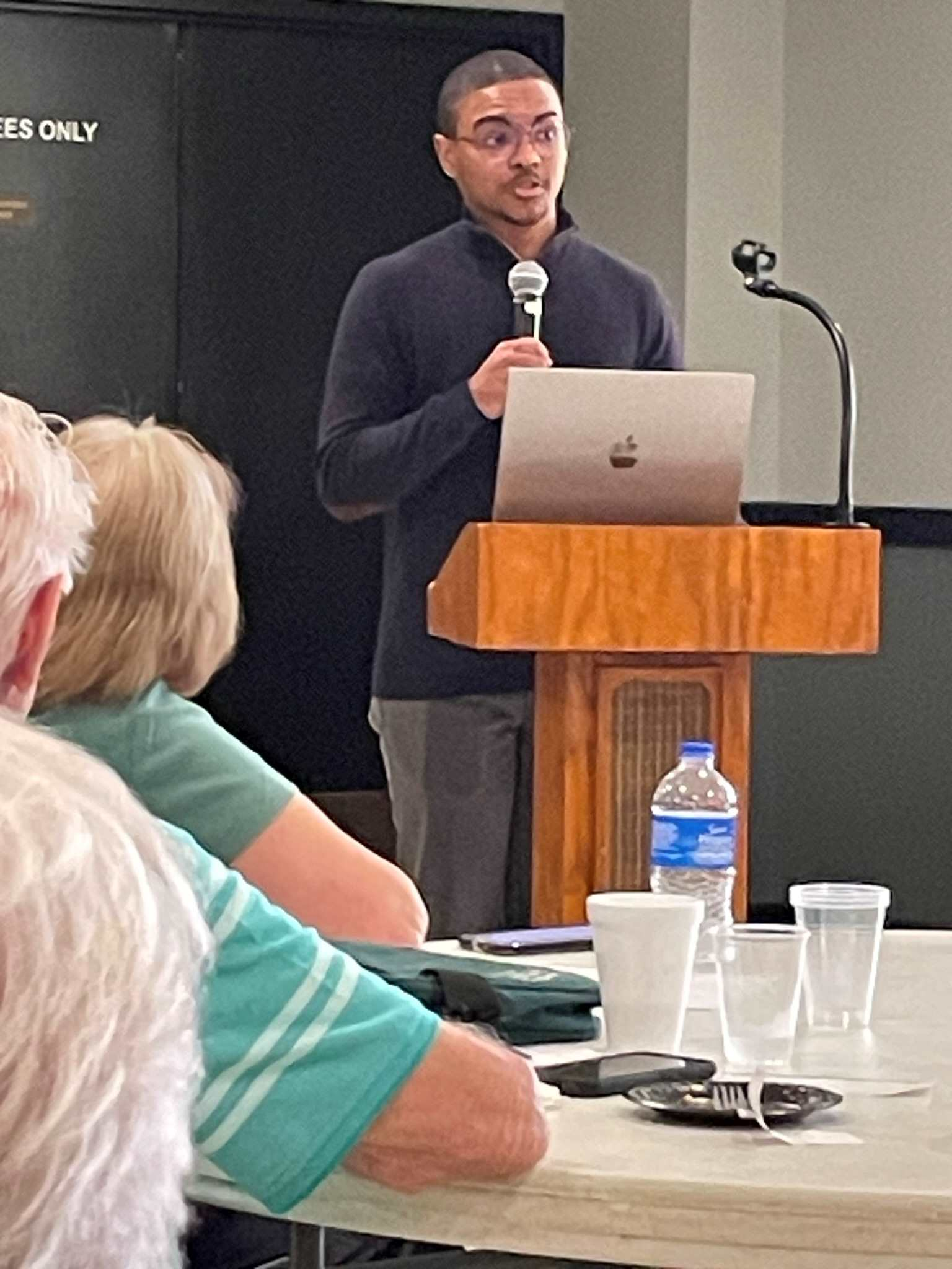

Donovan Burden was introduced by member Dan Larson. He holds classes to teach people how to use the Internet most effectively for their wants and needs. Donovan explained ways to search.

1. Know who you want to reach, those with similar interests.

2.Explore online platform.

3. How to engage your audience as with voice or photos.

4. Engage an activity with your audience.

5. Measure your efforts.

It can be difficult to determine what is true.

Dan, this was an interesting and different program.

**A**CTIVE MEMBERS Home Office or Cell

# Austinson, Paul 288-8735 273-5518

[**pjaustinson43@gmail.com**](mailto:pjaustinson43@gmail.com)

Borcherding, Don 282-1783 259-2679

[dpborcher@hotmail.com](mailto:dpborcher@hotmail.com)

Carlson, Dan 285-1098 272-5215

[Danhope3904@msn.com](mailto:Danhope3904@msn.com)

Graham, Charlie***** 507 358-8567 [Cgraham120@charter.net](mailto:Cgraham120@charter.net)

Hull, Linda 282-8399

[lindahull1025@yahoo.com](mailto:lindahull1025@yahoo.com)

Ilvedson, Ronald*** 529-0551 [peterturkel@gmail.com](mailto:peterturkel@gmail.com)

Jorgenson, Austin **Secretary** 413-2134

[Austj4@gmail.com](mailto:Austj4@gmail.com)

Kalmes, Bill **Treasurer** 289-4056 288-3277

[w.kalmes@smithschafer.com](mailto:w.kalmes@smithschafer.com) cell 951-7552

Krsnak, Roger **Co-President** 2023 282-2872 358-5020

[rdkrsnak@me.com](mailto:rdkrsnak@me.com) cell 358-5020

Lawson, Del 951-4006

[drdel22@aol.com](mailto:drdel22@charter.net)

Lun, Al **Webmaster** 289-3937 507-269-3853

[albert.lun@gmail.com](mailto:albert.lun@gmail.com)

Maddox, Colleen **Co-President** 287-0318 280-7911 (cell)

[landherrmaddox@gmail.com](mailto:landherrmaddox@gmail.com)

Nehring, Irv 775-6857 cell 226-1494

[inehring@frontiernet.net](mailto:inehring@frontiernet.net) **Auditor & Budget Advisor**

Nelsen, David 533-0225

[perryford90@yahoo.com](mailto:nrockford9@aol.com) cell 815-243-1223

Nelson, Daniel 507-884-9829

[dan61nelson@gmail.com](mailto:dan61nelson@gmail.com)

Schultz, Bonnie 280-6078 529-4830

[bonnies@uwolmsted.org](mailto:bonnies@uwolmsted.org)

Tompkins, Mary cell 273-5012

[Mtompkins14@charter.net](mailto:Mtompkins14@charter.net)

Warren, Clare, 254-2087

[Clarew60@gmail.com](mailto:Clarew60@gmail.com)

16 Active members as of Oct 2023

*Senior Member **Privileged Member ***Honorary Member

****Senior & Long Term Perfect Attendance

*****Life Member

The preceding list reflects the official roster of active members according to Kiwanis International. If a name is missing or one is present that should not be, please let C. Warren know. ***District & International web sites:***

[***www.kiwanis.org***](http://www.kiwanis.org/) [www.mndak.org](http://www.mndak.org)

***Jim Bouquet 651-560-4292

***Bob Fiss 288-7480

The Kiwanis Club of Rochester meets every Thursday at the Meeting Room at the Eagles

917 15th St. SE

Meetings last about one hour. Lunch is served including an entree, fruit, salad, and drink for ($14.00 )

~~~~~~~~~~~~~~~~~~~~~~~~~~~~~~~~~~~~~~~~~~~~

***Newsletter Changes***

*Remember to call* ***Clare Warren at 254-2087*** *if you have anything you feel is newsworthy. We are trying to get the newsletter out every other week. It can be effective if you feed in the right information. Feel free to contribute something for publication!*

Be sure to read the roster once in awhile and report any errors to C. Warren

***Why not!*** *If you have a computer, why not try to receive the Kiwanis* ***Newsletter via e-mail.*** *It is a quick and easy way for us to get the letter to you on time. We now have 17 ACTIVE members receiving it regularly. They enjoy the ability to get it in COLOR.*

at [www.kiwanisroch.org](http://www.kiwanisroch.org) 2022-23



*Colleen Maddox*

*Roger Krsnak Co- Presidents*

*Immed. Past Presidents*

*Austin Jorgenson*

*Bill Kalmes Treasurer*

*??? Secretary*

***Committees***

***Club Rep to District***

***Membership, Growth & Education***

***Public Relations***

***Community Services***

***Youth Service & YCPO***

*,*

***Programs***

*Circles of Service*

***Human and Spiritual Values***

***Finance***

***Donations/Charities***

***Co-Presidents next yr. are***

***(Still no names for co-Presidents for next year)***